Android Studio Giraffe. https://developer.android.com/studio
- Tools – Android - SDK Manager:
– Version 10 Android version 29 and 11Android version 30
- Google APIs Intel x86 ATOM System Image (If this doesn’t work, then install another AVD)
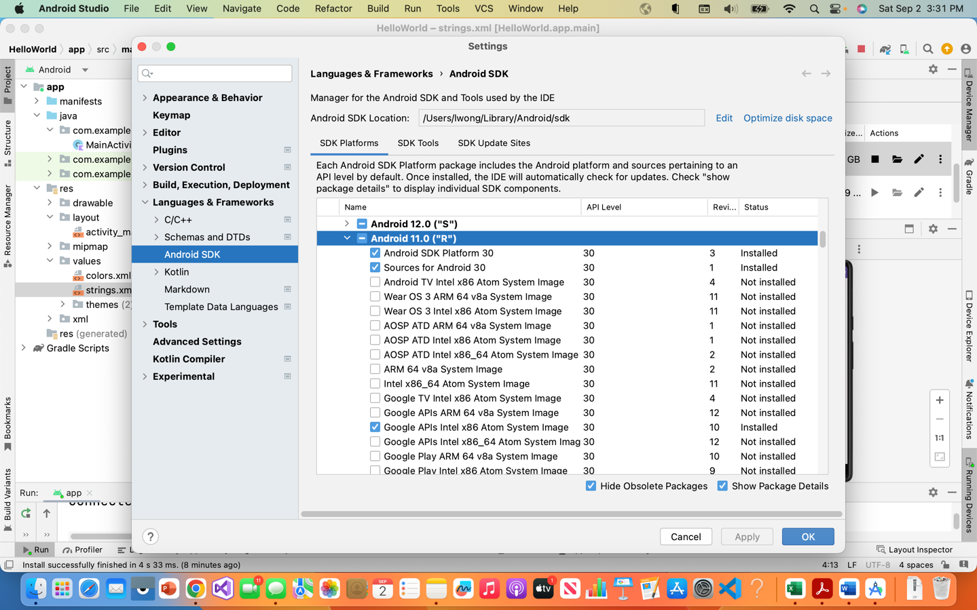

It is to your benefit and time if you have a phone to run your programs on. If your phone is not of version 10 or 11, you will want to also download that Android version in the SDK manager.
